

**Mitsubishi PS3CFO Inverter 3.5 Ton**

**Rs. 298,990/-**

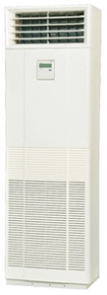

**Product Features**

* Air Vane Technology
* Auto Swing
* power mode
* precise system control technology
* concealed LED display

**Specification**

**Type** Floor Standing AC

**Cooling (Btu/h)** 41000

**Voltage (V)** 220-240

**Power Input (W)** 3800

**EER (Btu/W-h-W/W)** 7.6-2.10